Annual Conference 2018 Press Release
Law Reform Commission Conference on Brexit and Law Reform in Ireland
CONFERENCE WILL ASSESS HOW BREXIT WILL AFFECT THE COMMON LAW IN IRELAND
CONFERENCE WILL ADDRESS THE CHALLENGES AND OPPORTUNITIES FOR LAW REFORM IN A POST-BREXIT CONTEXT
CONFERENCE WILL ALSO ADDRESS THE EU LEGAL FRAMEWORK, REGULATORY SUPERVISION, LEGAL PRACTICE AND THE CONTINUING RELEVANCE OF THE ENGLISH COMMON LAW
The Law Reform Commission is hosting a conference on the 12th of November (9am to 1pm) at the Radisson Blu Royal Hotel, Golden Lane, Dublin 8 on the subject of Brexit and Law Reform in Ireland. This conference aims to explore a range of legal issues arising from the United Kingdom’s decision to leave the European Union, including:
- how Brexit is likely to affect the Irish (common law) legal system;
- the challenges and opportunities that are likely to arise for law reform in the context of post-Brexit Ireland;
- the European Union legal framework and how it is likely to evolve;
- the effect on legal practice;
- regulatory governance concerning food and drugs; and
- issues pertaining to public law and regulatory supervision.
Further information is available on the Commission’s website, lawreform.ie.
The conference on the 12th of November forms an important part of the Commission’s public engagement, and should address a range of issues of considerable importance, both to law reform in Ireland, and to the wider debate on Brexit.
Conference speakers
The conference begins with an opening address from Ms Justice Mary Laffoy, President of the Law Reform Commission.
There will then follow a keynote address by Advocate General Gerard Hogan, Court of Justice of the European Union, on the theme: “How Will Brexit Affect the Common Law of Ireland?”
The first session of the conference is on Law Reform in Post-Brexit Ireland and Europe. The first speaker at this session is Patrick Leonard, SC, Bar of Ireland. This will be followed by presentations by Professor Blanaid Clarke, McCann FitzGerald Chair in Corporate Law, Trinity College Dublin, the University of Dublin, and Professor Federico Fabbrini, Full Professor of EU Law, School of Law & Government, Dublin City University, and Director, DCU Brexit Institute.
The second session of the conference in on Regulatory Issues and Legal Practice. The first speaker at this session is Ken Murphy, Director General of the Law Society of Ireland. This will be followed by presentations by Maree Gallagher, Solicitor, Covington and Burling, and Professor Christopher McCrudden, Professor of Human Rights and Equality Law, Queen’s University Belfast.
The sessions will be followed by contributions and comments from delegates to the panel, as well as a question and answer session.
The conference will be attended by approximately 140 delegates from a wide section of public bodies, including Government Departments and academia, as well as delegates from private sector organisations with an interest in this area.
Biographical notes for the conference speakers are attached as under.
For further information/interview with conference speakers or a Commission representative contact: Winifred McCourt, McCourt CFL T: 087-2446004
Background Notes for Editors
The Law Reform Commission is an independent statutory body whose main role is to keep the law under review and to make proposals for reform. To date, the Commission has published over 200 documents (Consultation Papers, Issues Papers and Reports) containing reform proposals. The majority of these proposals have influenced the drafting and content of reforming legislation.
Biographical Notes for the Conference Speakers
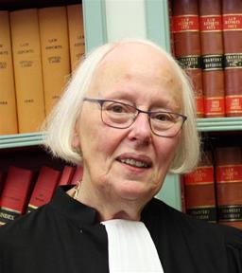
Ms Justice Mary Laffoy, President of the Law Reform Commission, graduated from University College Dublin with a B.A. degree in 1968. Subsequently, between 1968 and 1971 she studied law at University College Dublin and at the Honourable Society of King’s Inns in Dublin. She was called to the Bar in July 1971.
She practised as a barrister from the Michaelmas term in 1971 until her appointment to the High Court. She was admitted to the Inner Bar in the Michaelmas term of 1987.
She was appointed a judge of the High Court in April 1995. While on the High Court Bench, she was primarily involved in civil litigation, principally in the area of chancery law. She was appointed to the Supreme Court in October 2013 and retired in June 2017.
Ms Justice Laffoy chaired the Citizens’ Assembly from July 2016 to June 2018, when it published its Final Report.
In October 2018, she was appointed President of the Commission.

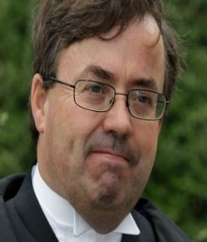
Advocate General Gerard Hogan Court of Justice of the European Union, has been an Advocate General member of the Court of Justice of the European Union since October 2018. Previously, he served as a Judge of the Court of Appeal from 2014 to 2018 and as a judge of the High Court from 2010 to 2014.
He was educated at University College Dublin, the University of Pennsylvania, Trinity College Dublin and the King's Inns. He was called to the Bar in 1984 and became a Senior Counsel in 1997.
He was a law lecturer and fellow in Trinity College Dublin from 1982 to 2007. He has authored leading texts on Irish Constitutional and Administrative Law, as well as numerous articles in law journals in Ireland and internationally.

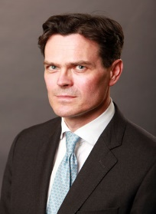
Patrick Leonard, SC, Bar of Ireland, became a Senior Counsel in 2013, and practises in civil law, particularly in professional regulatory law, commercial and property litigation.
He was a founding member of the Professional Regulatory and Disciplinary Bar Association, is a member of the Editorial Board of the Bar Review, and was first elected to the Bar Council in 2016. In 2016/2017, he was Chair of the Arbitration and ADR Committee, and co-ordinated a series of lectures on International and Domestic Arbitration for members.
He co-ordinated the Bar of Ireland’s efforts to promote Irish law and Irish Lawyers to the international market, leading to the recent joint submission to Government by the Bar of Ireland, the Law Society, a number of leading firms, and the IDA.
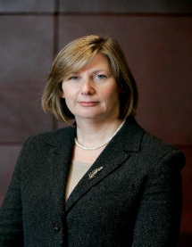
Professor Blanaid Clarke McCann FitzGerald Chair in Corporate Law, Trinity College Dublin, the University of Dublin, was, prior to taking up this position, Associate Professor in the Law School in University College Dublin where she was one of the founding members of the UCD Centre for Corporate Governance. Her research interests include company law, corporate governance, financial services law, securities law and takeover law and she has published extensively in these areas. She is on the editorial boards of the Journal of Business Law and Palmer's Company Law and was one of the editors of Legal Studies (2011-2016). Blanaid is a member of the European Commission Informal Expert Group on Company Law and prior to that was a member of the European Commission's Reflection Group on the Future of EU Company Law. She is a member of the European Model Company Act Group, the University of Oslo's Sustainable Companies project and the European Corporate Governance Institute. She works with the Irish Takeover Panel and is a member of the European Securities and Markets Authority (ESMA) Takeover Bids Network. Blanaid was appointed to the board of the Irish Central Bank Commission in 2010 and reappointed in 2013. She is the Irish representative on the OECD Corporate Governance Committee. In January 2018, Blanaid was invited to become a member of the European Securities and Markets Authority (ESMA) Securities and Markets Stakeholder Group.

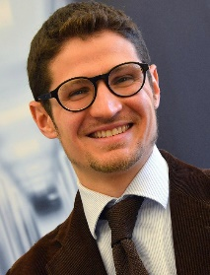
Professor Frederico Fabbrini Full Professor of EU Law, Director, DCU Brexit Institute, is Full Professor of EU Law in the School of Law & Government at Dublin City University, and Director of the DCU Brexit Institute. He holds a PhD in Law from the European University Institute and previously had academic positions in the Netherlands and Denmark. He is the author of Fundamental Rights in Europe (Oxford University Press 2014) and Economic Governance in Europe (Oxford University Press 2016) as well as the editor, among others, of The Law & Politics of Brexit (Oxford University Press 2017). He regularly engages with EU institutions and national governments, and has presented his work to, among others, the European Parliament, the European Central Bank, the European Commission, the European Court of Justice and the UK Financial Conduct Authority.
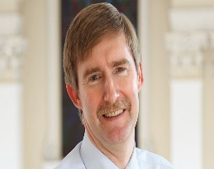
Ken Murphy Director General, Law Society of Ireland, took up the office of the Director General in 1995. At the time of his appointment as Director General, he was a partner with the large commercial law firm A & L Goodbody and a senior member of the Council of the Society. As Director General he frequently acts as spokesman for the Society in the media and he has represented the Society before Dáil Committees and as a Society nominee on Ministerial Working Groups. He also works very closely with the Law Society’s President (currently, Patrick Dorgan, Partner, Ronan Daly Jermyn, Solicitors) and both will frequently represent the Society at meetings throughout Ireland of local Bar Associations and also at international meetings of their counterparts from other countries.

Maree Gallagher Solicitor, Covington and Burling, is an Irish qualified solicitor who advises clients on EU food and life sciences law and policy. Ms. Gallagher has over twenty years of experience working with companies to bring their products to market. She is regarded as one of Europe's leading crisis management experts and has extensive experience advising FMCG companies on product recall and reputation management across the EU. Ms. Gallagher’s expertise covers drugs and devices with a particular emphasis on biologics and GxP, food and beverages, AGRI, and consumer products. Her practice covers a very wide spectrum from product licensing to composition, labelling, and marketing. Her clients include large public companies as well as multinationals operating in the Life Sciences and FMCG sector across Ireland and the EU. Ms. Gallagher also represents businesses facing regulatory enforcement action and she acts as a strategic and public affairs adviser in her specialist areas.
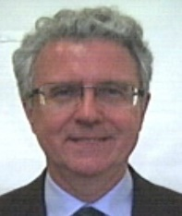
Professor Christopher McCrudden Professor of Human Rights and Equality Law, Queen’s University Belfast, is also William W Cook Global Law Professor at the University of Michigan Law School. Until 2011, he was Professor of Human Rights Law at the University of Oxford, and a Fellow of Lincoln College, Oxford. He studied law at Queen’s University Belfast, Yale University, and Oxford University. He holds a first law degree from Queen’s, an LL.M. degree from Yale, two doctorates from Oxford University (a D.Phil and a DCL), and an honorary LL.D. from Queen’s.
From 2011 to 2014, he held a Major Research Fellowship from the Leverhulme Trust. In 2013-14 he was a Fellow at the Straus Institute at New York University Law School. In 2014-15, he was a Fellow of the Wissenschaftskolleg zu Berlin, and is currently Chair of its Advisory Committee. He is a practicing Barrister at Blackstone Chambers in London, and has been called to both the Northern Ireland Bar and the Bar of England and Wales. His main research focus is on human rights law. Currently, his research deals with the foundational principles underpinning human rights practice. He was awarded the American Society of International Law’s prize for outstanding legal scholarship in 2008. Professor McCrudden is a Fellow of the British Academy and (from 2018) a Member of the Royal Irish Academy.

