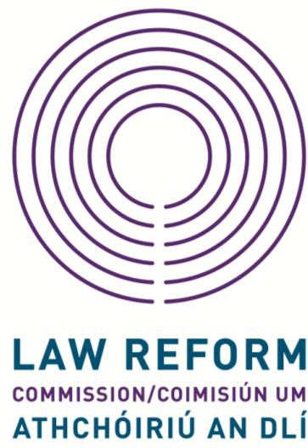
ANNUAL CONFERENCE 2019

ADDESSING TWO THEMES

Technology and Privacy in the Digital Era
&
Reform of Sexual Offences Law

Wednesday 13th November 2019
9:00 – 12:45

Radisson Blu Royal Hotel

Golden Lane

Dublin 8

Timetable

9.00 Registration

9.30 Welcome address
Ms Justice Mary Laffoy President of the Law Reform Commission

9.45 Session 1: Technology and Privacy in the Digital Era

Speaker: Dr John Danaher, Law School, NUI Galway

Speaker: Moyagh Murdock, CEO, Road Safety Authority

10.45 Break

11:15 Session 2: Reform of Sexual Offences Law

Speaker: Noeline Blackwell, CEO, Dublin Rape Crisis Centre

Speaker: Commissioner Tom O’Malley

12.15 Contributions and comments from Delegates to Panel, Questions and Answers

12.45 Close of Conference
Ms Justice Mary Laffoy President of the Law Reform Commission

BIOGRAPHIES
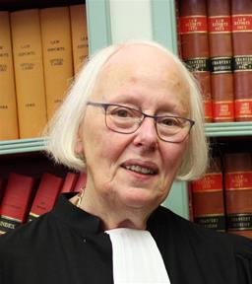
Ms Justice Mary Laffoy, President of the Law Reform Commission, graduated from University College Dublin with a B.A. degree in 1968. Subsequently, between 1968 and 1971 she studied law at University College Dublin and at the Honourable Society of King’s Inns in Dublin. She was called to the Bar in July 1971.
She practised as a barrister from 1971 until her appointment to the High Court. She was admitted to the Inner Bar in 1987.
She was appointed a judge of the High Court in April 1995. While on the High Court Bench, she was primarily involved in civil litigation, principally in the area of chancery law. She was appointed to the Supreme Court in October 2013 and retired in June 2017. Ms Justice Laffoy chaired the Citizens’ Assembly from July 2016 to June 2018, when it published its Final Report. In October 2018, she was appointed President of the Commission.

Dr. John Danaher,
Senior Lecturer, Law School, NUI Galway, holds a BCL from University College Cork (2006); an LLM from Trinity College Dublin (2007); and a PhD from University College Cork (2011). He was lecturer in law at Keele University in the UK from 2011 until 2014. He joined NUI Galway in July 2014. John's research focuses on the ethical, legal and social implications of new technologies. He maintains a blog called Philosophical Disquisitions, and produces a podcast with the same title. He also writes for the Institute for Ethics and Emerging Technologies. In 2019, his book Automation and Utopia: Human Flourishing in a World Without Work was published by Harvard University Press.

Noeline Blackwell, Chief Executive Officer, Dublin Rape Crisis Centre, is a human rights lawyer who previously worked as the Director of FLAC, the Free Legal Advice Centres and as a solicitor in private practice. She has been a member of a number of NGO boards and of a statutory board. She was a member of the Commission on the Future of Policing. She currently sits on the boards of the Immigrant Council of Ireland and Front Line Defenders. Noeline was appointed as Chief Executive Officer for the Dublin Rape Crisis Centre in 2016.

Moyagh Murdock,
Chief Executive Officer,
Road Safety Authority, has been in the transport sector for over 20 years in various capacities. In her early career she spent 10 years in the airline industry having worked first in Bombardier in Belfast as an aircraft systems engineer and subsequently at TEAM Aer Lingus. Prior to taking up the CEO role in the RSA, she was Chief Operating Officer for Bus Éireann after having joined the company in 2007 as the Deputy Chief Mechanical Engineer with responsibility for the fleet maintenance and garage operations. As Chief Operating Officer, she had responsibility for Road Passenger Operations, Schools Transport as well as the Information Technology and Business Systems for the company. Moyagh comes from Newry and graduated from Queen's University Belfast with a B.Eng. Mechanical Engineering. In 2012 she was awarded an MBA from Dublin City University (DCU) and also holds a Certificate of Professional Competence in Road Transport Operations Management.
Commissioner Tom O’Malley, Senior Lecturer in Law, NUI Galway, is also a practising member of the Irish bar where he specialises in constitutional law, administrative law and criminal law. He was educated at NUI Galway where he received a Master’s Degree in Classics and the LL.B. degree, and at Yale University where he received the LL.M. degree. He has been a member of the NUI Galway Law School since 1987 and has taught a wide range of public and private law subjects. He is a former Visiting Fellow at the University of Oxford Criminology Centre and has served on many bodies and committees dealing with aspects of law reform. He is the author of 10 books including Sentencing Law and Practice (3rd ed, 2016), Sexual Offences (2nd ed., 2013); Sentencing: Towards a Coherent System (2011), The Criminal Process (2009) and Sources of Law (2nd ed, 2001). He has also published numerous articles and book chapters. He has given guest lectures at many Irish, British, European and American Universities and he taught a postgraduate course in comparative criminology at the University of Leiden in 2012. He is also currently chair of the Department of Justice and Equality’s Expert Working Group on Review of the Investigation and Prosecution of Sexual Offences.

