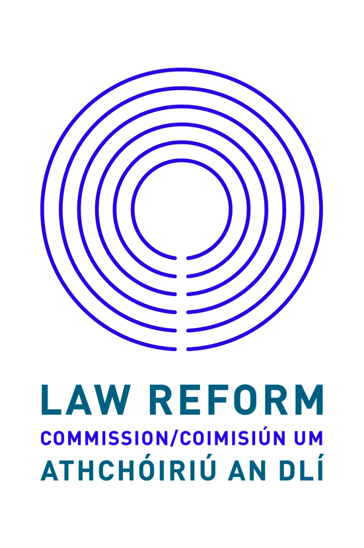

CANDIDATES’ INFORMATION BOOKLET

PLEASE READ CAREFULLY

LEGAL RESEARCH ACCESS INTERNSHIP

at the

Law Reform Commission

Closing date: 31 May 2021 at 12 (noon)

The Law Reform Commission is
committed to a policy of equal opportunity.

Telephone Number: (353) 1 637 7609
Email: internship@lawreform.ie
Web: www.lawreform.ie

Legal Research Access Internship

Law Reform Commission

The Law Reform Commission is a statutory body established by the Law Reform Commission Act 1975. The Commission has five members - the President, the Full-time Commissioner, and three part-time Commissioners.

Its role is to keep the law under independent, objective and expert review, to make consequent recommendations for law reform and to make current law accessible for all.

Legal Research Internship Access Scheme: Background Information

The Legal Research Intern Access Scheme has been created to provide an internship opportunity in the Law Reform Commission for current final year or post-graduate students in law who come from socio-economically disadvantaged backgrounds or have disabilities.

The internships will provide successful applicants with paid work experience in a legal environment and the opportunity to develop skills and confidence as part of a research team.

The aim of the access internship is to increase diversity in the legal profession and to improve access to opportunities for students from underrepresented backgrounds. Through the access internship, we seek to promote greater diversity in the legal sector. We are mindful of the evidence of indirect barriers to entry to legal professions which are likely to impact on socio-economically disadvantaged groups in particular (Hook Tangaza (2018) Review of Legal Practitioner Education and Training).

Public bodies in Ireland have a responsibility to promote equality, prevent discrimination and protect the human rights of their employees, customers, service users and other affected by their policies and procedures. This is a statutory obligation known as the Public Sector Duty for Equality and Human Rights. The statutory duty is set out in Section 42 of the Irish Human Rights and Equality Commission Act. While the Law Reform Commission is an equal opportunities employer, we have created this access scheme to further promote equality.

Role of a Legal Research Intern

Under the supervision of the Director of Research, Deputy Director of Research and a Senior Researcher, the Legal Research Intern will:

- complete research tasks to assist with providing a legal research service to the Commission,
- assist a Senior Researcher with preparing draft papers, Consultation Papers or Reports covering law reform,
- attend and participate at conferences and meetings, and
- undertake such other duties as may from time to time be assigned by the Commission.

The Legal Intern’s contribution will be acknowledged when a Consultation Paper or Report on a relevant project is published.

Essential Requirements
Candidates must, on or before 1 April 2021

- Be in their final year of study towards an honours degree or an equivalent qualification (at least a Level 8 on the National Framework of Qualifications) in Law or a qualification, acceptable to the Law Reform Commission as equivalent, in which Law was taken as a major subject; or
- Be pursuing a post-graduate qualification in law; and
- Have accessed a Higher Education Institution through an Access Programme / Access Route as school leavers, or mature students.

In addition, candidates must possess and be able to demonstrate:

- A good knowledge of Irish law and the Irish Legal System (including EU Law) and, ideally, knowledge of the ECHR system.
- Relevant undergraduate legal research experience.
- Good information technology skills.
- Attention to detail.
- The ability to write and present research/information in a concise, accessible and plain English style.
- The ability to plan, prioritise and monitor tasks in an organised way.
- Excellent interpersonal and team working skills.

Eligibility
Candidates must be permitted to work in Ireland.

Stipend
A stipend is available for successful candidates of €471.20 per week less applicable deductions, including PAYE, PRSI and USC.

Duration
The internship will be of two-months’ duration.

Applicants should be available to commence during the month of June or July 2021. Some flexibility around start dates will be afforded.

Hours of Attendance
Hours of attendance will be as fixed from time to time but will amount to on average not less than 43 hours and 15 minutes gross or 37 hours net per week.

Some flexibility in hours of work can be afforded in consideration of any caring responsibilities.

Place of Work
Successful candidates would ordinarily be based at the Commission offices, Styne House, Upper Hatch Street, Dublin 2. However, it is likely that the internship will be completed remotely due to the ongoing restrictions arising from the Covid-19 pandemic. Remote internships can also be facilitated for those based outside of Dublin who may be unable to locate to Dublin for the internship.

How to Apply
The application form is available at www.lawreform.ie.
To apply, you must:

- Complete all sections of the Law Reform Commission application form.
- Ensure the application form is completed accurately, as it will be used as a computer input document and you may be shortlisted based on information supplied.

In applying, you should note that:

- any inaccuracy in completing the form may result in rejection so is in your own interest to ensure that the information supplied in all sections is correct.

- if it is necessary to continue on a separate sheet, you should set the information out in the same format as in the application form.

Closing Date
The completed application form must be forwarded by e-mail to internship@lawreform.ie not later than 12 pm (noon) on 31 May 2021.

Applications received after the closing date and time will not be accepted.

Selection Methods
The methods used to select the successful candidate for this post will include:

- Shortlisting (if necessary) of candidates on the basis of the information contained in their application form. It is therefore important to provide a detailed and accurate account of your experience on the application form.
- If shortlisted, a competitive interview.

It is expected that interviews will take place (online) in June 2021.

Confidentiality
Subject to the provisions of the Freedom of Information Act 2014, applications will be treated in strict confidence.

Candidates’ obligations Candidates should note that canvassing or providing false information will result in their exclusion from the process.

Data Protection Acts 1988 to 2018
When your application form is received, we create a computer record in your name, which contains much of the personal information you have supplied. This personal record is used solely in processing your candidature. Such information held on computer is subject to the rights and obligations set out in the Data Protection Acts 1988 to 2018. You are entitled under these Acts to obtain, at any time, copy of information about you, which is kept on computer.

