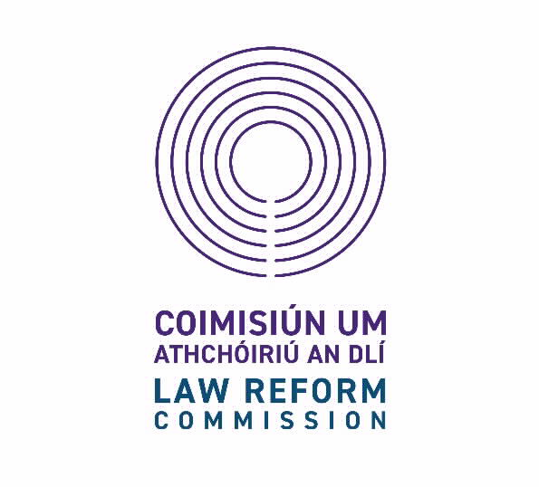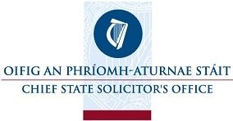

CANDIDATES’ INFORMATION BOOKLET

PLEASE READ CAREFULLY

LEGAL RESEARCH ACCESS INTERNSHIP

at the

Law Reform Commission.

the Office of the Attorney General.

the Office of the Director of Public Prosecutions.

and

The Chief State Solicitor’s office.

Closing date: Thursday, 7 March 2024 at 12 noon

The Law Reform Commission, the Office of the Attorney General, the Office of the Director of Public Prosecutions and the Chief State Solicitor’s Office are
committed to a policy of equal opportunity.

Telephone Number: (353) 1 631 4000
Email: internship@ag.irlgov.ie
Web: www.attorneygeneral.ie
Legal Research Access Internship

Law Reform Commission

The Law Reform Commission is a statutory body established by the Law Reform Commission Act 1975. The Commission has five members - the President, the Full-time Commissioner, and three part-time Commissioners. Its role is to keep the law under independent, objective and expert review, to make recommendations for law reform and to make current law accessible for all.

The Office of the Attorney General

The Attorney General is the advisor to the Government in matters of law and legal opinion and a Constitutional Officer. The Office, therefore, is the central legal service of the State, providing advice and draft legislation and supervising conduct of litigation involving the State.

The Office of the Director of Public Prosecutions

The Office of the Director of Public Prosecutions was established by the Prosecution of Offences Act 1974. Its mission is to provide a Prosecution Service that is independent, fair and effective. The Director is independent in the performance of her functions. The Director enforces the criminal law in the courts on behalf of the People of Ireland; directs and supervises public prosecutions on indictment in the courts; and gives general direction and advice to An Garda Síochána in relation to summary cases and specific direction in such cases where requested.

The Chief State Solicitor’s Office

The CSSO has a mission to provide the highest standard of professional legal services to the Government, its Departments and Offices, as economically and efficiently as possible and to support adherence to the rule of law. The Statement of Strategy 2023-2026 takes account of the Programme for Government and the significant developments in the internal and external environments within which the CSSO operates. As outlined in the Statement of Strategy, our vision is to inspire excellence in our people, be at the forefront of legal developments and deliver an unrivalled service to our clients.

The function of the Chief State Solicitor is to act as Solicitor to Ireland, the Attorney General, Government Departments and Offices. The wide remit of the Civil Service requirements of the CSSO means that Officers are involved in many aspects of legal work.

Legal Research Internship Access Scheme: Background Information

The Legal Research Internship Access Scheme has been created to provide internship opportunities in the Law Reform Commission, the Office of the Attorney General, the Office of the Director of Public Prosecutions and the Chief State Solicitor’s Office for current final year law students who come from socio-economically disadvantaged backgrounds or have disabilities.

The internships will provide successful applicants with paid work experience in a legal environment and the opportunity to develop skills and confidence as part of a research/ legal team.

The aim of the access internship is to increase diversity in the legal profession and to improve access to opportunities for students from underrepresented backgrounds. Through the access internship, we seek to promote greater diversity in the legal sector. We are mindful of the evidence of indirect barriers to entry to legal professions which are likely to impact on socio-economically disadvantaged groups in particular (Hook Tangaza (2018) Review of Legal Practitioner Education and Training).

Public bodies in Ireland have a responsibility to promote equality, prevent discrimination and protect the human rights of their employees, customers, service users and other affected by their policies and procedures. This is a statutory obligation known as the Public Sector Duty for Equality and Human Rights. The statutory duty is set out in Section 42 of the Irish Human Rights and Equality Commission Act 2014. While the Law Reform Commission, the Office of the Attorney General, Office of the Director of Public Prosecutions and Chief State Solicitor’s Office are equal opportunities employers, we have created this access scheme to further promote equality.

Successful candidates will be placed on a panel in order of merit. Positions will be filled from the panel and successful candidates will be placed in one of the four participating organisations.

Role of a Legal Research Intern

The role of the Legal Research Intern will vary depending on which organisation they are placed in. Under the supervision of an assigned manager and mentor, the Legal Research Intern will:

- complete research tasks,
- assist with preparing or prepare memorandums, presentations, case notes, papers, reports, and notes of meetings, as the case may be,
- attend and participate at conferences and meetings, both internally and externally with stakeholders where required, and
- undertake such other duties as may from time to time be assigned by the Law Reform Commission, the Office of the Attorney General, Office of the Director of Public Prosecutions or Chief State Solicitor’s Office.
- Participation in and providing support in relation to knowledge management tasks.

Where the Legal Research Intern is placed with the Law Reform Commission, their contribution will be acknowledged when a Consultation Paper or Report on a relevant project is published.

Essential Requirements
Candidates must, on or before 7th of March 2024:

- Be in their final year of study towards an honours degree or an equivalent qualification (at least a Level 8 on the National Framework of Qualifications) in Law or a qualification, acceptable to the Law Reform Commission as equivalent, in which Law was taken as a major subject; and
- Have accessed a Higher Education Institution in Ireland through an Access Programme / Access Route as school leavers, or mature students. or
- Be registered with, and receiving supports from, a Disability Support Service in a Higher Education Institution in Ireland.

In addition, candidates must possess and be able to demonstrate:

- A good knowledge of Irish law and the Irish Legal System (including EU Law) and knowledge of the ECHR system.
- Relevant undergraduate legal research experience.
- Ability to research and analyse.
- Good information technology skills.
- Attention to detail.
- The ability to present and communicate research/information in writing, in a well-structured, clear, concise, comprehensive and plain English style.
- The ability to plan, prioritise and monitor tasks in an organised way to deliver results.
- Excellent interpersonal and team working skills.

Candidates will also be expected to be able to demonstrate the competencies for a
Legal Research Intern role, please refer to Appendix 1.

Eligibility
Candidates must be permitted to work in Ireland.

Stipend
A stipend is available for successful candidates of €534.34 per week less applicable deductions, including PAYE, PRSI and USC.

Duration
The internship will be of two-months’ duration.

Start Date
Successful applicants should be available to commence internships on the 4th of June 2024.

Hours of Attendance
Hours of attendance will be as fixed from time to time but will amount to on average not less than 41 hours and 15 minutes gross or 35 hours net per week.

Some flexibility in hours of work can be afforded in consideration of any caring responsibilities.

Place of Work
Successful candidates would ordinarily be based at the Commission offices, Styne House, Upper Hatch Street, Dublin 2; the Office of the Attorney General, Merrion Street, Dublin 2, the Office of the Director of Public Prosecutions, Infirmary Road, Dublin 7, the Chief State Solicitor’s Office in Osmond House, Little Ship Street, Dublin 2.

Successful interns will be required to work fulltime in the Dublin offices they are assigned to throughout the duration of the programme.

How to Apply
The application form is available at www.attorneygeneral.ie
To apply, you must:

- Complete all sections of the application form.
- Ensure the application form is completed accurately, as it will be used as a computer input document and you may be shortlisted based on information supplied.

In applying, you should note that:

- any inaccuracy in completing the form may result in rejection so it is within your own interest to ensure that the information supplied in all sections is correct.
- if it is necessary to continue on a separate sheet, you should set the information out in the same format as in the application form.

Closing Date
The completed application form must be forwarded by e-mail to internship@ag.irlgov.ie no later than 12 noon on Thursday, 7th of March 2024.

Applications received after the closing date and time will not be accepted.

Selection Methods
The methods used to select the successful candidate for this post will include:

- Shortlisting (if necessary) of candidates on the basis of the information contained in their application form. It is therefore important to provide a detailed and accurate account of your experience on the application form.
- If shortlisted, a competitive competency-based interview.

It is expected that interviews will take place online in March 2024.

Confidentiality
Subject to the provisions of the Freedom of Information Act 2014, applications will be treated in strict confidence.

Candidates’ obligations
Candidates should note that canvassing or providing false information will result in their exclusion from the process.

Data Protection Acts 1988 to 2018
When your application form is received, we create a computer record in your name, which contains much of the personal information you have supplied. This personal record is used solely in processing your candidature. Such information held on computer is subject to the rights and obligations set out in the Data Protection Acts 1988 to 2018. You are entitled under these Acts to obtain, at any time, copy of information about you, which is kept on computer.

Appendix 1: Key Competencies for effective performance as a Legal Research Intern

Applicants should demonstrate that they meet the below competencies in their application forms including in their employment record role descriptions, answers to the questions and personal statement.

Applicants who are shortlisted for interview should demonstrate how they meet the competencies below in their answers to the competency-based interview questions.

Specialist Legal Knowledge, Expertise and Self-Development

- Knowledge of Irish law and the Irish Legal System (including EU Law) and knowledge of the ECHR system;
- Demonstrable undergraduate legal research experience and knowledge of relevant research methodologies;
- Develops and maintains the skills and expertise required to perform in the role effectively, e.g. keeping up to date with national and international developments;
- Clearly understands the role, objectives and targets of the organisations;
- Is committed to self-development and continuously seeks to improve personal performance.

Information Management/ Processing – Ability to Research and Analyse

- Researches issues thoroughly, consulting appropriately to gather all information needed on an issue;
- Understands complex issues quickly, accurately absorbing and evaluating different types of data (including numerical data);
- Approaches and delivers all work in a thorough and organised manner;
- Draws appropriate conclusions from information;
- Follows procedures and protocols, understanding their value and the rationale behind them;
- Keeps high quality records that are easy for others to understand;
- Suggests new ways of doing things better and more efficiently.

Communication Skills

- Presents information in a clear and logical manner, verbally and in writing;
- Ability to write in a plain English style;
- Actively listens to others and tries to understand their perspectives/ requirements/ needs;
- Is respectful, courteous and professional, remaining composed, even in challenging circumstances;
- Can be firm when necessary and communicate with confidence and authority.

Teamwork/ Interpersonal Skills

- Shows respect for colleagues and co-workers;
- Develops and maintains good working relationships with others, sharing information and knowledge, as appropriate;
- Offers own ideas and perspectives;
- Understands own role in the team, making every effort to play their part.

Ability to Deliver Results

- Takes responsibility for work and sees it through to the appropriate next level;
- Completes work in a timely manner;
- Adapts quickly to new ways of doing things;
- Checks all work thoroughly to ensure it is completed to a high standard and learns from mistakes;
- Writes with correct grammar and spelling and draws reasonable conclusions from written instructions;
- Identifies and appreciates the urgency and importance of different tasks;
- Demonstrates initiative and flexibility in ensuring work is delivered;
- Is self-reliant and uses judgement on when to ask manager or colleagues for guidance.

Drive and Commitment to Public Service Values

- Consistently strives to perform at a high level and deliver a quality service;
- Serves the Government and people of Ireland;
- Is thorough and conscientious, even if work is routine;
- Is enthusiastic and resilient, persevering in the face of challenges and setbacks;
- Is personally honest and trustworthy;
- At all times, acts with integrity.

